

**Design Studio #4 - Weekly Progress Report #18**

DS Instructor: Gülbin DURAL

Partners:

* Fatih ÇALIŞ
* Fatih ÇAM
* Recep GÜNAY
* Huzeyfe HİNTOĞLU
* Sarah ILYAS

In this week, we have performed demonstration to the Instructor Gülbin DURAL. Before the demonstration, we have made some modifications on the robot. Firstly, we have mounted the final version of the shooting header. This part of the mechanism has been printed by 3D printer as well. The drawing of the header is shown in Figure 1. Also, we have built game field, and finally, we got everything prepared for demonstration. The demonstration has been done successfully. Mainly two things have been tested in the demo. The first criteria for success was ability of the live video stream from robot to the screen up to 30 meters distance. We had no problem with this. Required video stream with good resolution and very less delay has been achieved. The second criteria was the ability of the control of the robot from the same distance. This task has been achieved as well. The user was able to command the robot as he desired, and give reactions to different situations successfully. After this demonstration, until the final demonstration, we have planned to make some improvements. First of all, the game field restricts the moving ability of the robot more than we expected because the field is small. Therefore, we are going to decrease the robot’s speed to minimize violations of game rules and unexpectedly bad reactions. We are aiming to do this change because sometimes the robot gives fast reactions and send the ball to the other side without driving and shooting it. Also, sometimes it rotates too fast and makes difficult to adjust shooting angle. We can make sure that decreasing the speed will be enough to make control of the robot easier.

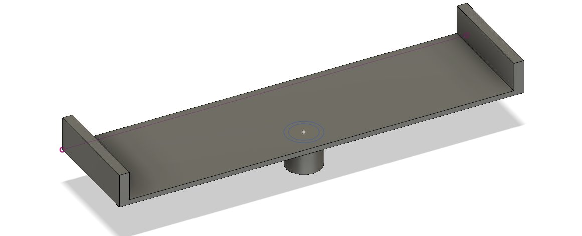

Figure 1: The 3D drawing of the header

The second improvement will be on shooting algorithm of the robot. The present algorithm is based on compressing spring on the mechanism with the motor mounted on the robot. The motor command is given by the controller. In this way, the robot must wait some time to compress the spring before it shoots. But, sometimes the robot has to give fast reactions and immediately shoots without wasting time. To do this, we will add one more channel read to the code and control it with the RC. The compressing action will already be taken with this channel and user will be able to shoot immediately without wasting time.